**WELCOME TO COP1000 – INTRODUCTION TO COMPUTER PROGRAMMING (with Python 3)**

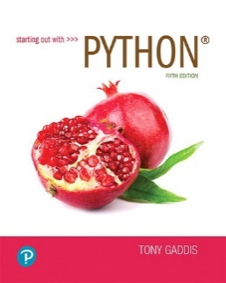**ARE YOU READY?**

You need **all** of these for course **start**:

* **Textbook**: Starting out with Python, **5th Edition** by Tony Gaddis (access code ***not*** required).
* **PC or Mac** with a **web cam**. Sorry, **Chromebooks, iPads and tablets will *not* suffice**.
* High speed **Internet** access.

**COURSE COMMUNICATIONS**

* **MyCourses email** is the best way to communicate with your professor.
* **It’s in your own best interest to be reachable**. **Do not block your email address**. Read your email.

**READ CHAPTER 1**

* Chapter 1 begins with some history and details about computer components and how they work.
* Section 1.3 introduces concepts needed later for the **Numbers Quiz**, so make a mental note of that.
* Section 1.4 covers how computer programs work and an introduction to programming languages.
* Section 1.5 is about getting Python and using **IDLE** in its two modes; **interactive** mode and **script** mode.

**INSTALLING PYTHON 3**

* As indicated on **page 20**, turn to **Appendix A** and follow the instructions exactlyto install **Python 3**.
* Be sure to check both options as shown on **page 801**.

**APPENDIX B : INTRODUCTION TO IDLE**

* This appendix covers **knowledge crucial** for success in this course. **Don’t just read it**.
* Start IDLE and **do** **everything** to learn how to use IDLE in both the **shell** window and **editor** window.
* The **shell** window (interactive mode) is for testing Python statements and displaying program output.
* The shell window is **not for writing programs.** Python programs are written in the **editor** window (script mode).
* Write the program shown on **page 807**. Note the importance of **indentation**.
* Save the program with the name **simple_loop4**, but don’t add .py to the name. IDLE does that for you.
* Run the program. If you were successful, the program’s **output will display in a shell window**.
* If the program doesn’t run properly, note the error message, and try again.

Python is very popular and highly rated. I hope you will agree with Professor Chris Piech after taking this course.

“It’s a magical experience learning how to code. It changes how you think, how you see yourself, and what you’re able to do."  
_ Prof. Chris Piech, Stanford University